Renewable Energy

- How much of the United States energy production is from renewable sources?

- What are the two major issues with our reliance on nonrenewable energy sources?

Hydroelectricity

- How does electricity work?

- What does a watt measure?

  - How many watts does a light bulb use?

  - How many watts does a car use?

- What does a kilowatt-hour measure?

- How do hydroelectric plants generate electricity?

- Describe how dams impact each of these aspects of the surrounding ecosystem:

  - Nutrients:

  - Sedimentation:

  - Ecosystem behind the dam:

  - Water temperature:

  - Fish:

- What disadvantage do dams have compared to fossil fuel or nuclear plants?

Wind Power

- How do wind turbines generate electricity?

- What are wind farms, and why are they necessary?

- What are the potential ecological impacts of wind power?

Geothermal Power

- How does geothermal power generate electricity?

- Explain what each of these wells at a geothermal plant do.

  - Injection well:

  - Production well:

Solar Power

- Why is solar power so difficult to harness if there is so much of it?

- How does parabolic solar collection convert sunlight into electricity?

- How do photovoltaic cells generate electricity?

- Shade in areas of this map of the United States that would be ideal for solar, hydropower, wind, and geothermal energy collection.
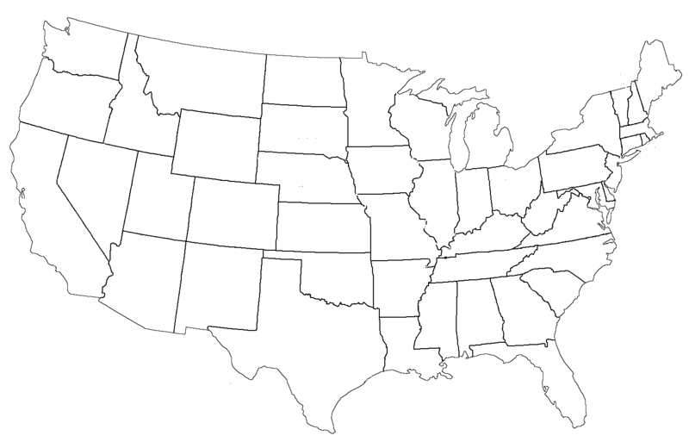
Solar | Hydro | Wind | Geothermal

Heat

- What is biomass?

- What are the two downsides of using biomass as a source of heat?

- How do passive solar heat structures gather heat from the sun?

- How do active solar heat structures gather heat from the sun?

Fuel for Transportation

- What are biofuels made from?

  - What is the biggest source of biofuel currently? Why is this a problem?

- What do hydrogen fuel cells do to generate electric current in a vehicle?

  - What is the disadvantage of using hydrogen for fuel?

- What type of battery is now used in electric and hybrid cars?

  - What advantage does this battery have over lead-acid and nickel-metal hydride?

Promoting Renewables and Efficiency

- What is energy efficiency a measurement of?

- Define each of these methods used to encourage renewable energy use by consumers:

  - Distributional surcharges –

  - Renewable portfolio –

  - Green pricing –

- What is the purpose of the federal energy star program?

- What caused the sudden spike in U.S. fuel economy during the 1970s? When did it begin to increase again?

