Radioactive Wolves

- What is the equivalent amount of radiation released by Chernobyl compared to the atomic bomb dropped on Hiroshima?

- Where is the Chernobyl exclusion zone located? Draw a circle on this map showing its location.

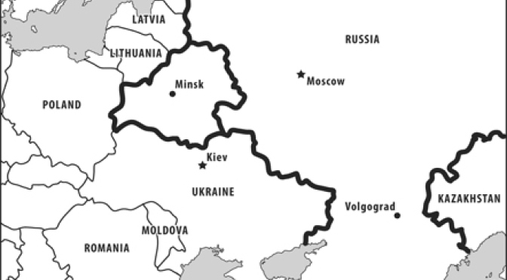

- Explain how access to the exclusion zone is restricted and protected.

- How has the radioactive fallout from the Chernobyl accident worked its way through the food web?

- Scientists are shown measuring radiation from moose bones leftover from a wolf kill. How radioactive are the bones?

- When do the scientists working in the exclusion zone need to wear all of their protective gear?

- Who were the “liquidators”?

- Explain how wolves can be used as a biological indicator of the overall health of the ecosystem.

- What human activity had the biggest impact on the wolf populations before Chernobyl?

  - Explain how these ecological changes have reversed since humans abandoned the exclusion zone.

- One of the scientists is shown gathering hair samples from an uncontaminated wolf den. Why would these samples be useful in studying animal life in the exclusion zone?

- Pripyat was a large city built mainly to provide a home for all of the employees of the Chernobyl nuclear plant. Describe what it looks like now.

- Why are the wolves so drawn to the abandoned buildings?

- What other species is used as an indicator, besides wolves?

- Why are laboratory rats kept and studied in the exclusion zone?

- What is the percentage of door mice born with genetic abnormalities? How does this compare with normal levels?

- Why are the catfish in the contaminated cooling pond so large?

  - How radioactive are the fish bones?

  - Are any of the fish in the exclusion zone safe for human consumption?

- Why are the large oak trees so important for storks? Where are they found?

- How are wolves actually slowing the return of the Pripyat marshes in the south part of the exclusion zone?

- How many wolves were estimated to be living in the exclusion zone? How does this compare to the control area?

Discussion Questions

- Overall, do you think the Chernobyl accident has actually been ecologically beneficial for the ecosystems within the exclusion zone? Which do you think is more damaging or dangerous to the biodiversity – the contamination from the radioactive fallout, or the presence of a large human population? Justify your answer.

- Imagine that you are trapped within the exclusion zone. As you hike your way out, you begin to feel hungry. Using what you know about biomagnification, which food source would be the safest? Explain how you know.
  - Mushrooms, fruit, and berries
  - Moose or deer meat.
  - Wolf meat.
  - Eagle meat.

- If your school and surrounding area were to be suddenly abandoned, how do you think nature would reclaim it? What ecosystem was present before it was built on? Would it return to its original state? How long would it take? What animal or plant populations would increase? Would you expect any species to actually decline without humans?

