Radio Bikini

- Explain how the military justified continued atomic bomb testing after World War II.

- Where in the Marshall Islands were the tests to take place?

- Why might this location have appealed to the United States military?

- What happened to the native islanders that were living in the atoll?

- How did the soldiers overall feel about being assigned to Operation Crossroads?

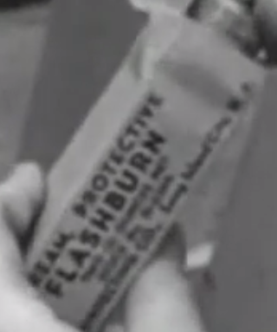
- As part of the experiment, animals were secured to the decks of some of the ships. They were given flashburn protective cream, which was intended to protect soldiers operating tanks from being burned by sudden flash fires. What was the purpose of this part of the experiment?

- The United States made a proposal at the United Nations called the Baruch Plan. This would have given control of atomic weapons over to the United Nations. Who opposed this plan?

- Representatives from a total of twenty-two countries attended the test bombing at Operation Crossroads. Why might the United States have invited them?

- What was the initial reaction from the people in attendance of the test?

- What happened to the target ships following the blast?

- What happened to the animals on board the target ships?

- What were the soldiers doing while waiting for preparations for the second test (Baker) to complete? How might they have been exposed to radioactivity?

- Did the native people have any idea what had been done to their island?

- How was the Baker test different than Able?

- Describe one of the concerns that Admiral Blandy addressed in his press conference before the Baker test.

- How did the fallout of the Baker blast compare with Able?

- How long after the blast did the sailors begin boarding the bombed ships? Did they have any protective clothing?

- How were the soldiers using the radioactive water? Were they warned about it?

- Why couldn’t the native islanders return to Bikini after the tests?

- What happened to the interviewed sailor, John Smitherman, after he returned home?

