Nuclear Power Plants

This is a diagram of a pressurized water reactor. This is the most common type of nuclear reactor found in the United States and throughout Western Europe. Identify and label each of the major parts of the power plant.

Word bank: control rods, fuel rods, reactor, primary loop, secondary loop, feedwater loop, water pump (x2), condenser (x2), turbine, generator, transmission lines, cooling tower, containment building.

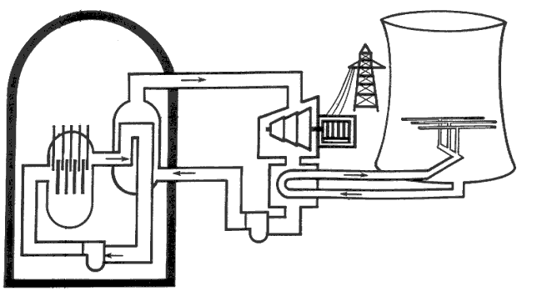
Image from nrc.gov

- In the primary loop, water passes through the pump and enters the reactor. Color the areas of liquid water blue. In the reactor, the water boils and turns to steam. It remains as steam until it passes by the secondary loop condenser. Color the areas of steam red.

- Color-code the water and steam in the secondary loop. Steam should be exiting the condenser. It becomes liquid water again below the turbine as it passes by the feedwater loop condenser.

- Color-code the water in the feedwater loop. It is liquid water until it passes through the condenser below the turbine, then steam until it enters the cooling tower.

Review Questions

- Why is the reactor coolant water kept contained within the primary loop instead of allowing it to mix with the feedwater and leave through the cooling tower?

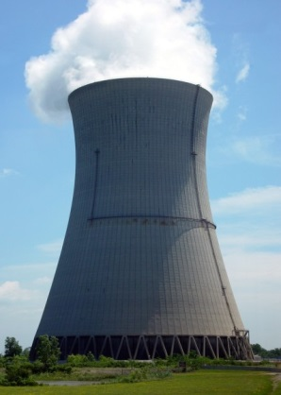

- You drive past a nuclear power plant cooling tower that looks like the image to the right. What is coming out of the tower and entering the air? Is it radioactive?

- Control rods can be inserted or removed from the core depending on the amount of electricity demand. What position does the diagram show the control rods in? Does this mean there is a high or low electricity demand?

- What are the outer walls of the containment building made of? Why is this important?

- All nuclear power plants have backup generators in case the plant stops producing electricity. Why is this necessary? What exactly are the generators providing power for? What might happen if these backup generators fail?

