Nuclear Energy

- What are radioactive atoms?

- What is ionizing radiation?

  - List three examples of ionizing radiation.
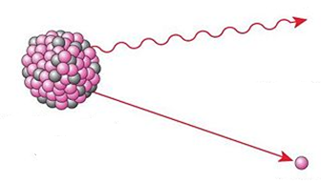

- Label the diagram below.

- Indicate the radioactive elements on this periodic table:

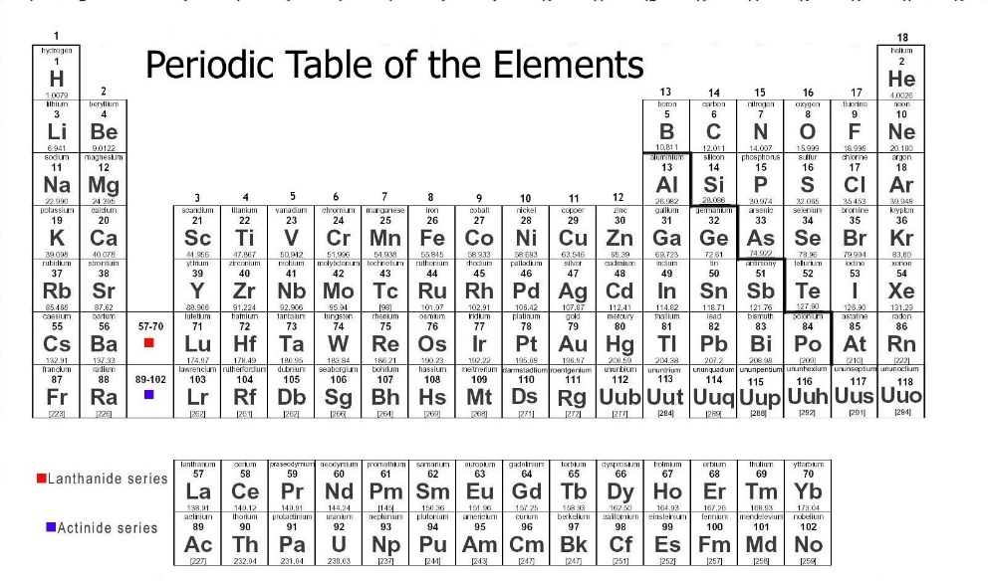

- What happened to the most of the particles that Geiger and Marsden aimed at the sheet of gold foil?

  - What happened to the others?

- What two conclusions were drawn from the gold foil experiment?

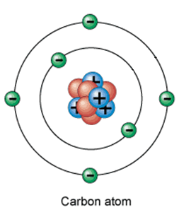
- Describe the charge and location of each of these particles within an atom. Label the carbon atom shown to the right.

  - Proton

  - Neutron

  - Electron

- How are isotopes of the same element different from each other?

- Write the three isotope notations used to indicate the uranium isotope with a mass of 235AMU.

- What happens to an atom undergoing nuclear fission?

  - What is released during nuclear fission reactions?

  - What occurs during a fission chain reaction?

Nuclear Testing

- What was the purpose of the 100-ton (0.1 kiloton) test?

- What was found in the desert following the Trinity test detonation?

- Describe the purpose of the three main components of a nuclear bomb.

  - Critical mass –

  - Neutron generator –

  - Bullet –

- What was the yield of the Hiroshima and Nagasaki nuclear bombs?

- Where was all of the post-World War 2 nuclear testing conducted?

- What was the purpose of the Operation Crossroads nuclear testing?

  - Why were lab animals strapped to the surface of the ships?

- Why did Glenn Seaborg refer to Shot Baker as a nuclear disaster?

- Define radioactive fallout –

- Define radiation sickness –

- Describe each of the factors that determine the severity of radiation sickness:

  - Dose –

  - Route of exposure –

  - Acute –

  - Chronic –

- Why were the first atomic bombs considered inefficient?

- How are hydrogen bombs different than the original fission bombs?

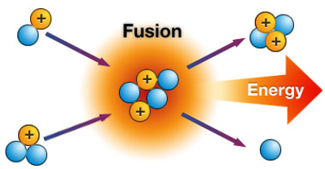

- Define nuclear fusion –

  - Label the diagram of nuclear fusion.

- What damage was caused by the Castle Bravo hydrogen bomb test?

- What did countries that signed the Partial Test Ban Treaty agree to do?

Nuclear Reactors

- What shift occurred following the the Atoms for Peace speech delivered by Eisenhower?

- Describe the role of each of these parts of a nuclear power plant:

  - Steam generator –

  - Turbine –

  - Generator –

  - Cooling tower –

  - Fuel rods –

  - Control rods-

  - Moderator –

  - Containment building –

- Do nuclear power plants produce pollution?

- About when did all nuclear plant construction stop in the United States?

- What is a meltdown?

- What was the primary cause of the Three Mile Island partial meltdown?

  - What damage was caused by this meltdown?
- List the three design flaws that led to the Chernobyl full meltdown.

- What is the Chernobyl exclusion zone?

- What was the primary cause of the Fukushima Daiichi full meltdown?

  - What damage was caused by this meltdown?

Nuclear Waste

- What is low-level nuclear waste?

- What is high-level nuclear waste?

- What is a half-life?

  - Given enough time, what will happen to a radioactive isotope?

- Cesium-137 has a half-life of __________________. How much would be left after…

  - 30 years?

  - 60 years?

  - 90 years?

- How long are the half-lives of short-lived isotopes?

- How long are the half-lives of longer-lived isotopes?

