Hydraulic Fracturing Webquest

How Fracturing Works
This is an interactive animation published by Halliburton, an energy company with a large hydraulic fracturing operation throughout the United States.

goo.gl/qltCdD

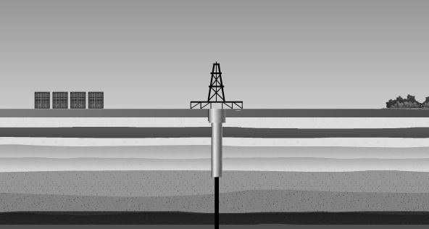

Hydrocarbons – The gaseous fuels extracted from the well. The biggest component is methane.
Proppant – A solid material, such as sand, that is injected to keep the fractures in the shale open.

Step 1 – Drilling

- Label the derrick and water table on the diagram above.

- What is the purpose of the derrick?

- What is the range of depths that groundwater is found in?

Step 2 – Vertical Drilling Phase

- Label the casing in the diagram above.

- What is the casing made of? Why is it there?

Step 3 – Drilling Continues

- How deep are the shale rock formations that the natural gas is found in?

Step 4 – Kick Off Point

- What is the kick off point?

Step 5 – Horizontal Drilling

- How long does the horizontal section of the drill travel?

Step 6 – Perforating the Well

- Why does the well need to be perforated?

Step 7 – Completion Phase

- Why is so much water needed during this phase?

- What is supposed to happen to the water that flows back up to the surface?

Step 8 – Hydraulic Fracturing

- What is actually “fractured” during hydraulic fracturing?

Step 9 – Hydrocarbons released
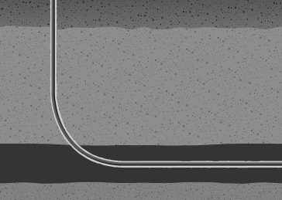
- Show what horizontal drilling part of the well now looks like by drawing the fractures and hydrocarbons on the diagram.

Fracking Map
Look at the fracking map at the Earth Justice Website: goo.gl/1PE45
earthjustice.org/features/campaigns/fracking-across-the-united-states

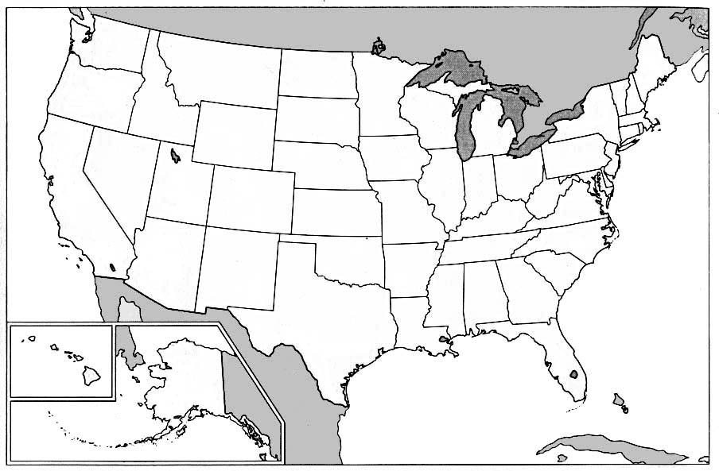

- Outline and label any areas of active fracking and proposed fracking in your state.

- List five states that have the largest active fracking areas.

- List the five states with the largest number of fracking accidents labeled on the map.

- Where is the closest “fracking accident” to where you live?

  - Summarize what happened during this accident.

- One of the most-affected towns by hydraulic fracturing accidents is Dimock, Pennslyvania. Type in Dimock, PA in the find a location box. Click on the accident mark for Dimock. Label it on your map.

- Open the Vanity Fair article at the bottom of the Dimock description. Read the first page of the article A Colossal Fracking Mess about what happened in Dimock. Outline what happened to the drinking water at the home of Craig and Julie Sautner.

- Visible effects on the water –

- Health effects experienced by the family –

- Actions taken by Cabot Oil and Gas –

- Actions taken by the Pennsylvania EPA –

- A few states immediately encouraged as much gas drilling as possible with few regulations. Other states temporarily banned fracking until it could be studied further. Look at the map one more time. List four states that are heavily affected by fracking accidents. Do you think the other states were justified in waiting?

