Fossil Fuels

- What are nonrenewable energy resources?

- What are fossil fuels?

Coal

- What is coal made of?

  - How does coal change as it is compressed?

- When did the Carboniferous Period take place?

  - What was the climate like during the Carboniferous period?

- What new trait did the trees of the Carboniferous period develop?

  - What happened when the trees died and fell over?

  - How did the trees alter the climate during this period?

- What geographic areas today have the greatest coal deposits?

- What is a coal seam?

- Describe each of these methods of coal mining:

  - Open-Pit

  - Strip

  - Mountaintop Removal

  - Subsurface

- What is acid mine drainage?

  - What does it look like?

- What disease often afflicts coal miners?

Oil

- Describe the process of oil formation.

  - What geographic areas are rich in oil deposits today?

- Describe the three steps of oil extraction:

  - Drill:

  - Lining:

  - Collection:

- Why are oil spills more likely to occur than accidents with coal?

- Describe three ways oil spills damage the environment:

  - Birds and mammals:

  - Benthic organisms:

  - Fish and plankton:

Natural Gas

- What is the primary component of natural gas?

- What is a gas flare?

  - Why do many oil drillers do this with their natural gas deposits?

- What is hydraulic fracturing?

  - What rock formation is usually fracked?

- What is the name of the large natural gas formation in the Eastern United States?

- Describe the three steps of fracking:

  - Fracking Fluid:

  - Fracturing:

  - Sand injection:

- Describe the two controversial issues behind hydraulic fracturing:

- Briefly describe each exemption granted to natural gas drillers:

  - National Environmental Policy Act:

  - Clean Air Act:

  - Clean Water Act:

  - Safe Drinking Water Act:

  - Resource Conservation and Recovery Act:

Applications of Fossil Fuels

- Label the different parts of a coal-fired power plant.

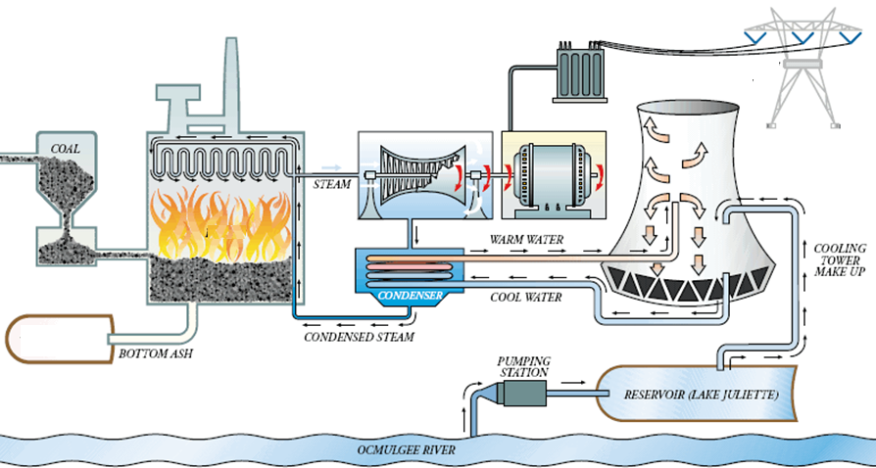

- Describe the role of each part in a coal-fired power plant.

  - Boiler:

  - Precipitator:

  - Turbine:

  - Generator:

  - Transmission Wires:

  - Cooling tower:

  - Ash storage pond:

- What happens to crude oil when it undergoes distillation?

  - List three products of crude oil distillation.

  - What is the majority of crude oil products used for?

- What is most natural gas used for?

Comparing Fossil Fuels

- What is the dirtiest-burning fossil fuel? What is the cleanest-burning?

- What does energy return on investment (EROI) measure?

  - What does a high ratio mean?

  - What does a low ratio mean?

  - Which fossil fuel has the highest EROI? The lowest?

- What does the reserves-to-production ratio estimate?

- What is the current R/P ratio of each fossil fuel?

  - Coal

  - Oil

  - Natural gas

- How much of the world’s energy supply is provided by fossil fuels?

