Coal Power Plants Webquest

How Coal Plants Work
This educational website, produced by various energy-related organizations in Australia, provides a brief tour of the major parts of a coal-fired power plant. URL: goo.gl/qVtGLp
oresomeresources.com/media/flash/interactives/qld_resources_coal_energy_plant/

- How is the coal transported to the power plant?

- What is the purpose of the hopper?

- What does the pulverizer/mill do?

- What is added to the coal dust before it is added to the boiler?

- What happens inside the boiler?

- Superheated steam is added to the turbines. What happens inside? Where does the steam go when it is cooled?

- What exactly does the turbine spin to generate the electricity?

- Why are there so many transformers placed outside the power plant?

- Where does the ash go from burning the coal?

Parts of a Coal Plant
Complete the coal-fired power plant puzzle, located here: goo.gl/UtDRSG
oresomeresources.com/media/flash/interactives/qld_resources_coal_energy_plant/
Once finished, label each of the structures below. Word bank: Turbine, boiler, reclaimer, electricity, generator, conveyor belt.

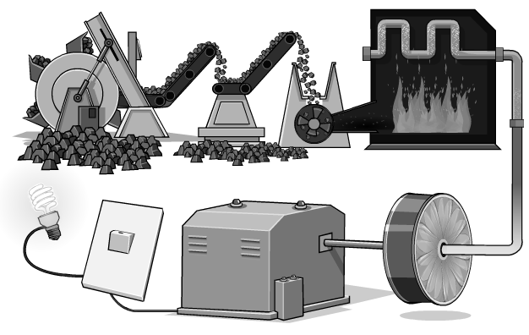
Nearby Coal-Fired Power Plants
Go to the interactive coal plant map here: sourcewatch.org/index.php/Existing_U.S._Coal_Plants or goo.gl/MCXR3v
Mark any coal plants in your immediate area on the map below. Include, at a minimum, any plants in your county and surrounding counties.

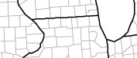

Visit the live wind map here: hint.fm/wind/
Draw a few arrows showing the general movement of air across your immediate area.

Based on current wind conditions, where would you expect to find air pollution resulting from coal plant emissions from what you marked on the map?

