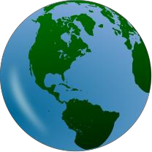
AP Environmental Science Summer Assignment
Welcome to APES!!!

AP Environmental Science is a lab-based course that is designed to examine ecological, biological, chemical, physical and environmental concepts and interactions. A student of this course should be familiar with local, regional and global concerns within their own environment.

General Guidelines:
- Read the directions for each section carefully!
- This project is due the first Friday we have school in September.
- It should be submitted via Google Classroom. Class code - e33ssjq
- Each section of the project must be typed and clearly labeled. Only section 3 – Math – should be handwritten.
- Each student is responsible for submitting their own project.
- Sign up to text message reminders through Remind.com – Send a text message to the number 81010. The message you should send is @h7df9d .
The objective of this summer assignment is to get you thinking environmentally and to refresh some math skills. I hope that you have an enjoyable, exciting, and educational summer! I look forward to meeting you in September!

Section 1: Experience the Natural World - Visit a natural outdoor area, go for a walk, and make some observations. Please go beyond your backyard. Here are some nearby places you could visit:

- South Shore Nature Center Bayview Avenue
East Islip, NY 11730 Phone: (631) 224-5436

- Seatuck National Wildlife Refuge 500 St. Marks Lane, Islip, NY Phone: 631-286-0485

- Southaven County Park
175 Gerard Rd, Yaphank, NY
Phone: (631) 854-1414

- Hecksher State Park East Islip, NY 11730 (631) 581-2100

On your walk, please do the following:
- Connetquot River State Park Preserve Sunrise Highway (south side), Oakdale Phone: (631) 581-1005

- Smith Point Park
1 William Floyd Pkwy
Shirley, NY
Phone: (631) 852-1313

- Bayard Cutting Arboretum Great River, NY
Phone: (631) 581-1002

- Sunken Forest Preserve
Sailers Haven, Fire Island National Seashore 631-597-6183
- Record the time, date, location, approximate duration of your outing.
- Record brief observations of the flora and fauna, the geology of the area, the type of path you are walking on (grass, sand, rock, etc). Specific details are not necessary (ex., “I saw two black turtles sunning themselves on a log…”) This should be one paragraph.
- Take photos during your walk. Include your favorite 3 photos.
- Find a quiet spot to sit for at least five minutes. Close your eyes and listen to the sounds around you. What sounds are natural? Are there human made sounds? Write a reflection of this experience. This should be one paragraph.
- Respond to the following in a brief paragraph:
  - Is this natural area really “natural”? Explain. How do you think it appeared 25 years ago, 200 years ago, and 20,000 years ago?

Section 2: Chemistry Review –
- For each of the following, write out the chemical name that goes with the symbol:
CO2 | CO | C6H12O6 | CH4 | N2 | NO2 | Hg
NH3 | NH4 | O2 | O3 | P | PO43- | S
SO2 | SO3 | H2SO4 | Pb | U | Rn

- Write at least a paragraph that explains the following:
  - What is the pH scale? What does it measure?
  - How do the numbers on the pH scale compare? Example – is a pH of 4 twice as strong as a pH of 2? Hint- the pH scale is not linear!
  - What are the average pH ratings of the following common substances in the environment?
Cite all sources!!
    - Blood
    - Rain
    - Freshwater (lake or river)
    - Ocean water

Section 3: Math Review – Complete the following math problems on a separate sheet of paper. This is the only part of the summer assignment that is to be handwritten. You can either take a picture of this work and include it as part of your final document or hand in separately on the first day of school.

The APES exam has a significant amount of math and does not allow the use of calculators! Most students find that with a little practice, the math is not difficult, but as many of us have not had practice with setting up and solving problems without a calculator in a long time, in the beginning it can be daunting.

Convert the following numbers to scientific notation: 1. 0.000006
2. 5400000
Convert the following numbers from scientific notation to standard numbers 3. 2 × 105
4. 4.4 x 10 -3
Complete the following multiplication and division problems. NO CALCULATORS! You must show all work to get credit.
5. 75 x 16
- 140 million divided by 7 billion

Complete each of the following problems including a detailed set up with labeled units and proper scientific notation. NO CALCULATORS! You must show all work to get credit.

- A population of deer had 200 individuals. If the population dropped 15% in one year, how many deer were lost? What is the total population of deer the next year?

- The concentration of mercury in a water supply changes from 10ppm (parts per million) to 56ppm over a ten-year period. What is the percentage change of the mercury concentration?

- Fire Island is about 800 meters wide and 50 kilometers long. Calculate the volume of water (in m3) if 5 centimeters of rain falls on Fire Island?

- A turtle was crawling at the rate of 38 cm per minute. How many kilometers would the turtle crawl in 2 hours?

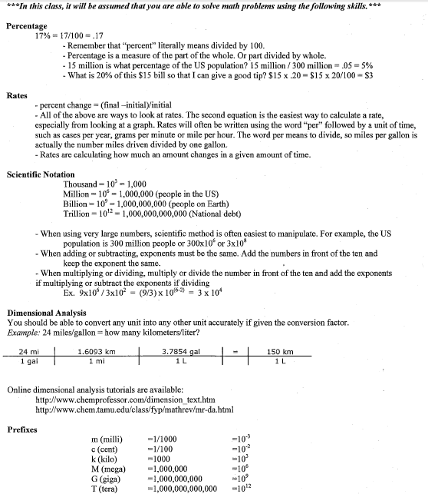

Section 4: Environmental Surveys / Ecological Awareness – Complete each survey and then write a
summary and reaction for each.

- Go to: http://www.watercalculator.org/ and complete the water footprint calculator. Record how much water you use as a family and as an individual. Copy and paste or screenshot your results to include into your final document.

After completing the survey, write a summary and a reaction to the survey.
  - In one paragraph tell me about the results of the survey and why you got the results you did.

  - In a second paragraph tell me about your reaction to the results. Was any of the information in the survey surprising to you? Which activity used more water than you thought? What can you do to use less water?

- Go to: www.nature.org/greenliving/carboncalculator/index.htm and find your individual carbon footprint.

Copy and paste or screenshot your results to include into your final document.

After completing the survey, write a summary and a reaction to the survey.
  - In one paragraph tell me about the results of the survey and why you got the results you did. How do your results compare to the average American overall? How do your results compare to the average American in each category on the pie chart? How do your results compare to an average person in the world?

  - In a second paragraph tell me about your reaction to the results. Was any of the information in the survey surprising to you? What can you do to reduce your carbon footprint?

- Go to: https://islandwood.org/footprint-calculator/ and find your ecological footprint. (For # 2 - use the U.S. Measurement System). Copy and paste or screenshot your results to include into your final document. Including … If each person in the world had the same Ecological Footprint as you, how many earths would it take to sustain our population?

After completing the survey, write a summary and a reaction to the survey.
  - In one paragraph tell me about the results of the survey and why you got the results you did. What are some areas suggested for improvement?

  - In a second paragraph tell me about your reaction to the results. Was any of the information in the survey surprising to you? What can you do to reduce your ecological footprint?

Section 5: Think Global! – Watch 5 of the following TED Talks and write a review to each including the following:

- A list of 5 facts you learned from watching the TED talk. These must be full sentences.

- No more than one paragraph personal reflection regarding the TED talks you chose. Include in your response how you think the TED talk is related to APES.

Remember: Each student is responsible for submitting their own work.

Choose 5 from the following:

**Jonathan Foley: The Other Inconvenient Truth https://www.ted.com/talks/jonathan_foley_the_other_inconvenient_truth

**Paul Greenberg: The Four fish we’re Overeating – and What To Eat Instead. https://www.ted.com/talks/paul_greenberg_the_four_fish_we_re_overeating_and_what_to_eat_instead

**Nancy Rabalais: The Dead Zone of the Gulf of Mexico
https://www.ted.com/talks/nancy_rabalais_the_dead_zone_of_the_gulf_of_mexico

**Shimon Steinberg: Natural pest control…using bugs https://www.ted.com/talks/shimon_steinberg_natural_pest_control_using_bugs

**James Balog: Time-lapse proof of extreme ice loss https://www.ted.com/talks/james_balog_time_lapse_proof_of_extreme_ice_loss

**Garth Lenz: The true cost of oil https://www.ted.com/talks/garth_lenz_images_of_beauty_and_devastation

**Dennis vanEngelsdorp: a plea for bees https://www.ted.com/talks/dennis_vanengelsdorp_a_plea_for_bees

**George Monbiot: For more wonder, rewild the world https://www.ted.com/talks/george_monbiot_for_more_wonder_rewild_the_world

** Boyan Slat: How the oceans can clean themselves:
https://www.youtube.com/watch?v=ROW9F-c0kIQ

** Taylor Wilson: Yup, I built a nuclear fusion reactor: https://www.ted.com/talks/taylor_wilson_yup_i_built_a_nuclear_fusion_reactor?referrer=playlist-the_end_of_oil

Make sure to include each of these in you final document

Checklist:

Section 1: Score /20
- I have visited a natural outdoor area beyond my backyard.
- I have recorded observations during my outing.
- I have included my 3 favorite photos.
- I have written a reflection of this experience.
- I have responded to the following statement in a brief paragraph: Is this natural area really “natural”?

Section 2: Score /20
- I have identified all of the chemical compounds and I am ready for a quiz.
- I have written at least one paragraph about pH and I am ready to explain it to someone else.
- I have cited all of the sources I used to find my information.

Section 3: Score /20
- I have read through the math review material and understand how to solve these types of problems.
- I have completed all of the review problems and am ready to take a math quiz.
- I have shown all work and it is handwritten.

Section 4: Score /20
- I have completed all 3 ecological awareness surveys.
- I have copy and pasted my results into my final document.
- I have written a summary and reaction after completing each.

Section 5: Score /20
- I have watched 5 TED videos and I have written a review for each.
- My reviews include 5 facts and these facts are written using full sentences.
- My reviews also includes one paragraph personal reflection and how I think the TED talk is related to APES.

*Above are the tasks you should complete this summer. This assignment is due the first Friday of school. All final materials should be typed and submitted via Google Classroom . Please organize all parts of this assignment into one word document.
Please include a cover page with your name.

